Avatar
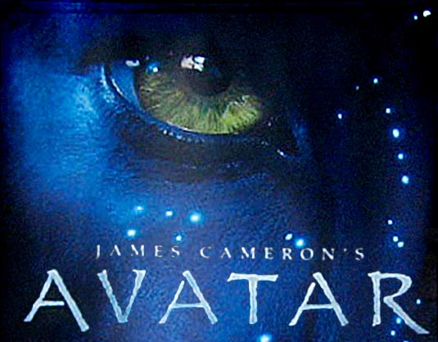

1) Avatar explores the themes of a. unity, b. fairness and c. equality, and the d. fight against
territorial greed. Please give an example for each theme as it is presented in the film.
a. _________________________________________________________________________________________
b. _________________________________________________________________________________________
c. _________________________________________________________________________________________
d. _________________________________________________________________________________________

2) Do you believe that the military was meant to be a last resort in solving problems or as depicted in the film Avatar, should it be a first option to settle disputes, as was the case in the 2003, U.S. invasion of Iraq?
___________________________________________________________________________________________
___________________________________________________________________________________________

3) The film Avatar shows the power that one person can have on a small group of individuals. Jake Sully (Sam Worthington) learns that the military cause is unjust, and he eventually switches sides. He is just a single person, but his actions lead to a chain of events that change Pandora forever. Is this realistic, can one person really make a difference or is this just something that can only happen in the movies. (Give examples to support your answer.)
___________________________________________________________________________________________
___________________________________________________________________________________________

4) Avatar, with all of its glorious special effects, and its revolutionary filmmaking methods, has brought many ills of society to light. What message does the film give, if any?
___________________________________________________________________________________________
5) James Cameron has arguably created an entirely new workflow for high-profile pictures that involves the collaboration and involvement of various crafts such as sound, bringing its creation much earlier into the film making process. Music cues, sound effects, and visual effects shots could be sent to a production center so that visual effect, sound and music technicians could tweak the work print. How does this new technology help filmmakers bring clarity to their films and make for better story telling? (Please include examples from the film)
___________________________________________________________________________________________
___________________________________________________________________________________________
6) Some feel that Avatar is an all-too-familiar tale of racial superiority, being the story of a white man who infiltrates a delightfully under-clothed indigenous culture, learns their ways, and manipulates circumstances to become their leader. If the Na'vi were portrayed as African Americans instead of Blue People, do you think the film would have been as well received or would audiences have boycotted it?
___________________________________________________________________________________________
___________________________________________________________________________________________

7) During the climactic battle scenes in Avatar, a sacred tree is destroyed that stands at the spiritual center of the Na'vi world. Do you think that High School Educators should use the movie Avatar, a 3D cartoon like fantasy film to teach historical facts about the destruction of the indigenous people of America or instead, should they go beyond what is taught in the text books and show how Native Americans were chased off their lands and forced to destroy their own sacred trees for firewood? (Much like the Na'vi, Native Americans suffered massive losses. It is estimated that over 40,000,000 Native Americans were massacred between 1492 and 1890.)
___________________________________________________________________________________________
___________________________________________________________________________________________
___________________________________________________________________________________________

8) Does the film support truly sensitive ecological understanding of the natural world or does it flaunt misconceptions that subvert it?
___________________________________________________________________________________________
___________________________________________________________________________________________
9) Some religious groups have depicted the film Avatar as sacrilegious and claim that it contains anti-religious undertones. They see the Na'vi as pagan like blue devils who have desecrated a “Garden of Eden” like world
in which they have no business being part of. Do you agree with this portrayal of the film or do you feel that certain evangelical ministries are just trying to create controversy and capitalize on the film’s success? (Please explain in detail and give examples of how various scenes in the film are either deliberately blasphemous or meaningful)
___________________________________________________________________________________________
___________________________________________________________________________________________
___________________________________________________________________________________________
___________________________________________________________________________________________
___________________________________________________________________________________________
___________________________________________________________________________________________

