UNFORGIVEN
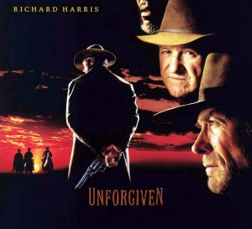

1) Describe the overall message that the film Unforiven communicates about violence?
_______________________________________________________________________________________________
_______________________________________________________________________________________________

2) How is the story a tale of retribution? Please explain.
_______________________________________________________________________________________________
3) How does the film radically redefine, and realistically debunk the grandeur and romanticism of the Western genre? _______________________________________________________________________________________________
_______________________________________________________________________________________________

4) The film is set in _____ _________, Wyoming.

5) The Style and Cinematography of the film is interesting in that at certain times during the film, the picture becomes so dark that the image goes completely black. What events occur in the film that cues this cinematic technique? _______________________________________________________________________________________________
_______________________________________________________________________________________________
6) How is William Munny’s (Clint Eastwood) Journey used as a Motif in the film? (A motif is a detail within a film that repeats itself throughout the story.) Examples of common motifs include colors, character traits, objects, locations, or situations) What other motifs are found in the film?
_______________________________________________________________________________________________
_______________________________________________________________________________________________
7) Near the end of the movie in the film’s final bar scene, William Munny stops to take a drink while standing in front of a mirror; however, we the audience, cannot see his reflection. What might this symbolize?
8) Silhouettes are used in the first and last scenes of the film, as backdrops to the story. Why does the director use this?

9) What is the significance and symbolism of the movie's title?

10) Why does Will initially hide his identity from the Kid? What causes Will to follow the Kid?

11) How does Will’s memory of Claudia affect him throughout the film?

12) Why does Ned decide to go with Will to Wyoming?

